Marton
Civic Centre
Feasibility Study Proposal

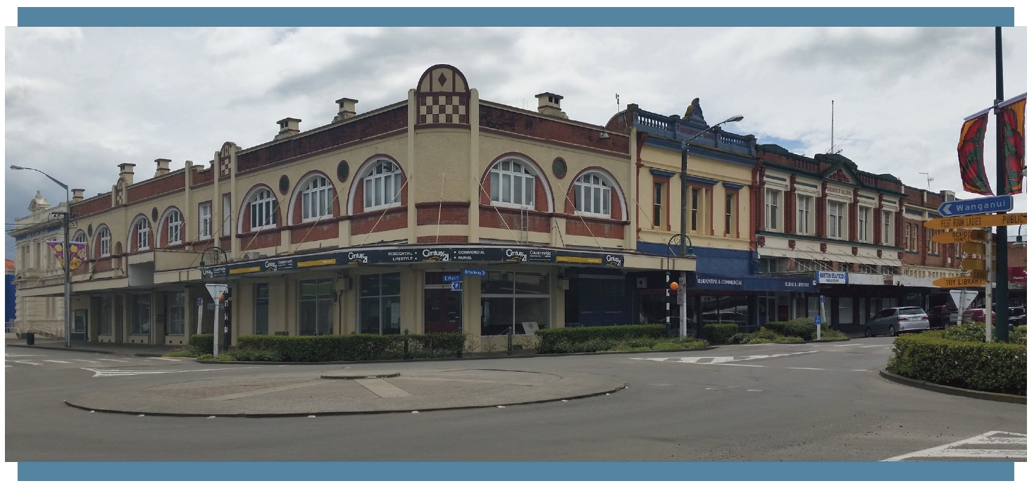
Contents
1.0 | Introduction | 1
2.0 | Objectives & Methodology | 4
3.0 | Presentation of Findings | 6
4.0 | Timeline for Delivery | 6
5.0 | Independent Endorsement | 7

1.0 Introduction
In December 2016, WSP Opus (formerly Opus International Consultants) was engaged by the Rangitikei District Council to complete a high-level concept design document providing an assessment of the Marton Heritage Precinct and options for the development of a Community Civic Centre utilising three Heritage-listed buildings within the Precinct, informed by the Rangitikei District Plan and the Marton Town Centre Plan (2014). The information provided in this introductory section has been adapted from that document.

Marton Heritage Precinct

The town of Marton (named Tutaenui until 1869) was founded in 1866 when three rural landholders each agreed to subdivide and sell 60 acres of their own land in response to growing settler demands. By the 1880s, Marton had become an important junction between the North Island Main Trunk Railway, and the line to New Plymouth via Wanganui. Marton’s two main streets, Broadway - running north-south - and High Street - running east-west at the southern end of Broadway – were lined with single and double storey buildings housing a variety of commercial premises. Owing to the availability of the resource, these buildings were predominantly constructed in timber, generally sharing common or party walls with adjacent buildings, leaving them highly vulnerable to fires.

The first fire occurred in 1879, and was followed by further fires in 1896, 1898, 1899, and 1912, and a series of arsons in 1922-27, destroying numerous buildings. Concurrently, the population of Marton was rapidly increasing, with 178% growth between 1891 and 1926. These factors drove the construction of larger and “less vulnerable” brick buildings between 1900 and 1926. While these buildings ranged in style, they were predominantly two storeys, with retail spaces at ground floor and accommodation or office space above; and generally included strong horizontal elements such as verandahs and decorative parapets. Together, they formed a homogeneity of height, form and materials, creating a unified built landscape.

While this built landscape has changed in the course of recent decades, a substantial amount remains intact. Approximately 35 pre-1930s buildings remain along Broadway and High Street, 16 of which are listed with Heritage New Zealand Pouhere Taonga. However, the prosperity that underpinned the development of this built landscape no longer exists. Marton’s economy has suffered as a result of a reduction in rail services, a downturn in manufacturing, poor connectivity to the State Highway Network, and a rise in private motor vehicle ownership which enables residents to travel easily out of town to larger centres. The town is in need of rejuvenation, and its heritage landscape is set to play a key role.

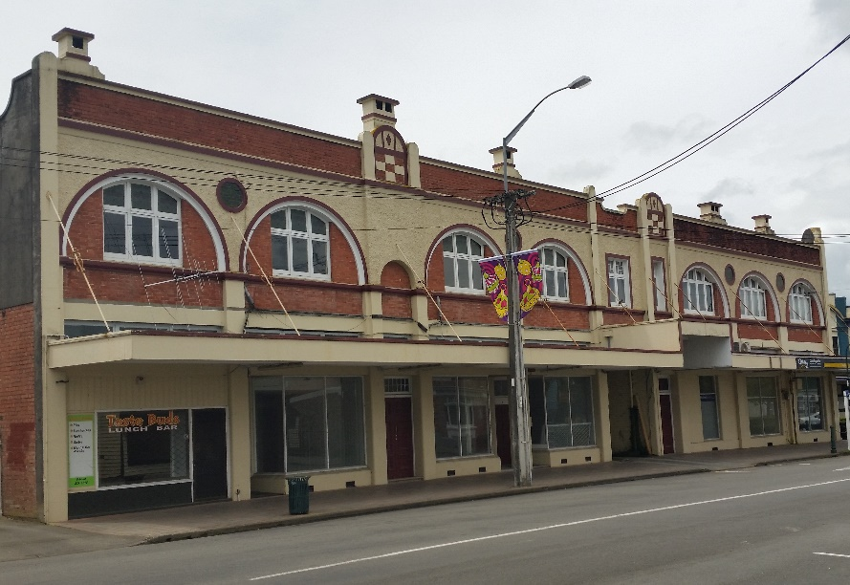
The heritage landscape of Broadway and High Street is recognised in the Rangitikei District Plan as the Marton Heritage Precinct. The Rangitikei District Council have identified the need to manage this precinct in a way that sustains the social, cultural and economic wellbeing of the community without diminishing heritage values. As the Marton Town Centre Plan (TCP) (2014) recognises, heritage buildings within the precinct reflect Marton’s strong and proud identity, and are the town’s greatest asset. Active reuse of these buildings is key to creating the vibrant “people place” envisioned in the TCP, providing quality spaces and facilities for locals and a “boutique” destination for those from further afield.
Figure 1: High Street Façade, Cobbler Building

Proposed Civic Centre Buildings

In 2016, the Rangitikei District Council purchased three buildings within the Heritage Precinct, on the northwest corner of Broadway and High Street:

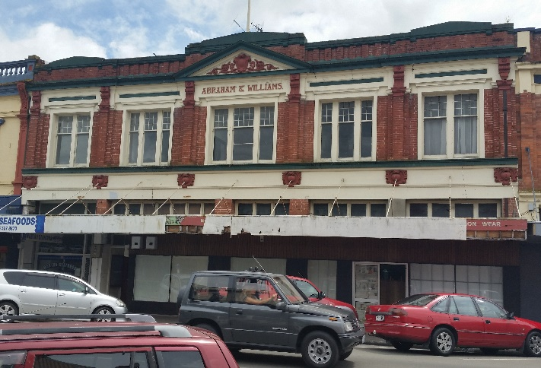
- Abraham and Williams Building, 304-310 Broadway
Designed for Abraham and Williams by W. T. Higgins, architect, in the Edwardian Free Classical style. It was built by local contractors Haddock and Hasell in 1915. The building is particularly significant due to its associations with the original owners and architect, for the quality of the Broadway façade, and for its contribution to the wider heritage precinct. It is listed as a Category 2 Historic Place (1240) and scheduled as a heritage building in the Rangitikei District Plan (H18).
Figure 2: Abraham and Williams Building, Broadway

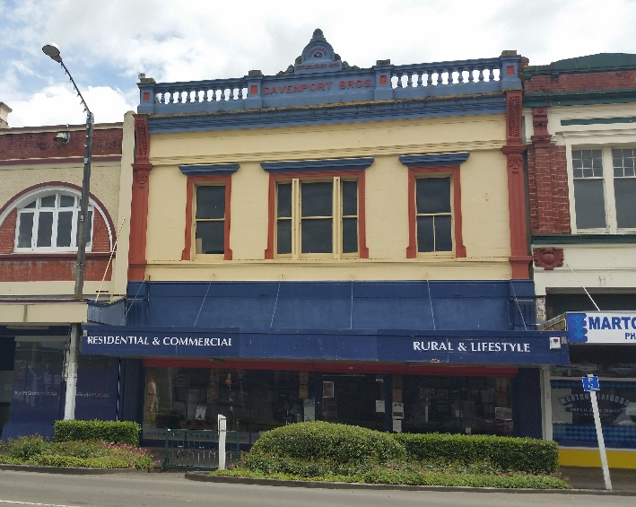
- Davenport Building, 312 Broadway
Designed by an unknown architect for the Davenport Brothers in the Edwardian Commercial Italianate style. It was built by local contractors Haddock and Hasell in 1905. The building is particularly significant due to its associations with the original owner, the quality of the Broadway façade, and what remains of its unique interior, as well as for its contribution to the wider heritage precinct. It is listed as a Category 2 Historic Place (1244) and scheduled as a heritage building in the Rangitikei District Plan (H22).

- Cobbler Building,314-318 Broadway
Figure 3: Davenport Building, Broadway

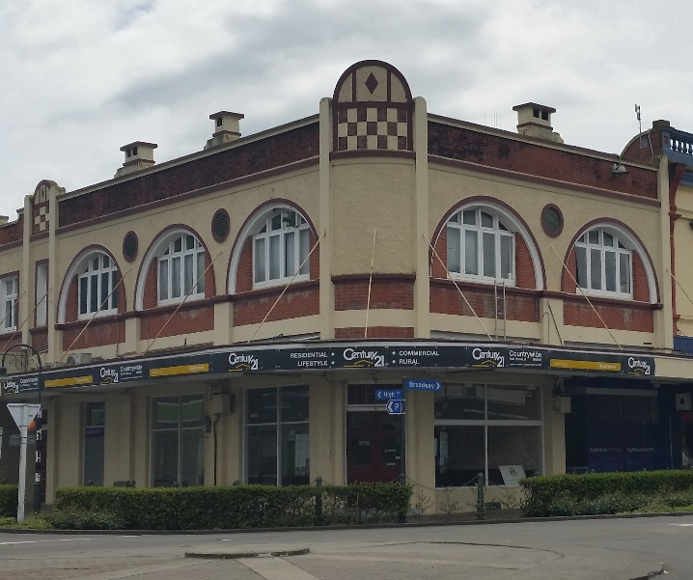
Designed for the Davenport Brothers by local architect Robin Hood in the Edwardian Free Style. It was built in two phases. The first portion, fronting Broadway and the corner with High Street, was constructed in 1913 by Haddock and Hasell. The second portion, fronting High Street, was constructed in late 1913 to early 1914 by Wanganui contractors Russell and Bignell. The building has particular significance associated with its architecture, being the only example of the true Edwardian Free style in Marton, and what remains of its unique interior, as well as for its contribution to the wider heritage precinct. It is listed as a Category 2 Historic Place (1243) and scheduled as a heritage building in the Rangitikei District Plan (H21).
Figure 4: Cobbler Building, corner High Street and Broadway

This prominent site forms the gateway to both Broadway and High Street, and has the potential to be the hub around which the rest of the Precinct develops. At present, the buildings are largely vacant, with limited options for ongoing use in their current condition.

As recognised by the ICOMOS New Zealand Charter, ongoing use of places of heritage value is vital for their preservation. Wherever possible, this use should be the same as, or consistent with the original use; however, new uses should be considered where this is not possible. Altering heritage buildings for new uses is now a common practice, and is known as “adaptive reuse’. The best examples of adaptive reuse are those that retain and conserve the significant heritage fabric of a building, while adding a contemporary layer that provides for the future.

Rangitikei District Council intends to be both an example of how adaptive reuse and restoration can be carried out within Marton’s Heritage Precinct; and an anchor for ongoing development in the area. However, these buildings are all constructed in unreinforced masonry and are considered to be earthquake-prone, which presents challenges to their reuse.

Earthquake-Prone Buildings Legislation

Marton is identified as an area of high seismicity under the Building (Earthquake Prone Buildings) Amendment Act 2016. The Act requires Territorial Authorities to identify Priority Earthquake Prone Buildings (EPBs) in their area within 2½ years, where Priority Buildings include those regularly occupied by 20 or more people, and any part of an unreinforced masonry building that could fall onto a public area. The owners of Priority EPBs must strengthen or demolish their buildings within 7½ years of receiving a final notice from the Territorial Authority. In the case of the three buildings proposed for the Marton Civic Centre, they are owned by the Rangitikei District Council; but they are not exempt from the time limits imposed by the Act.

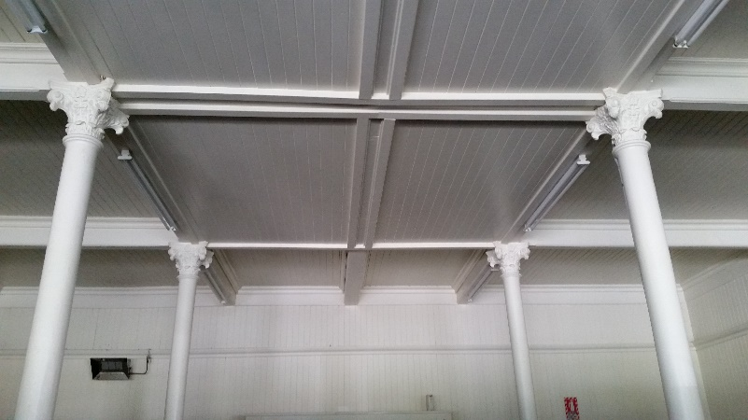
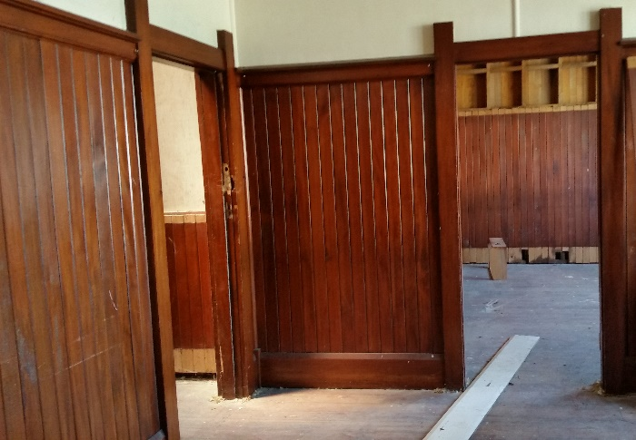

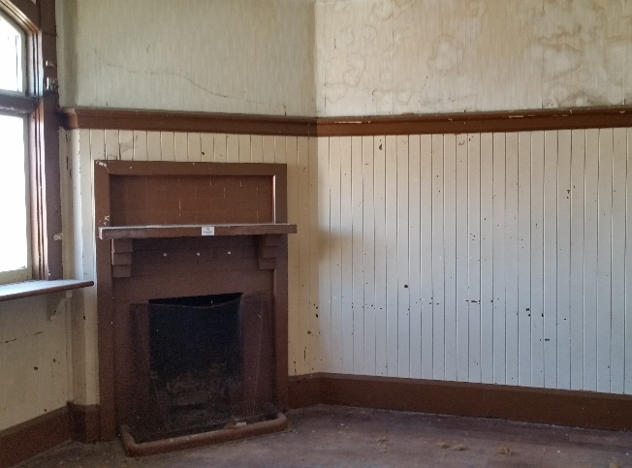
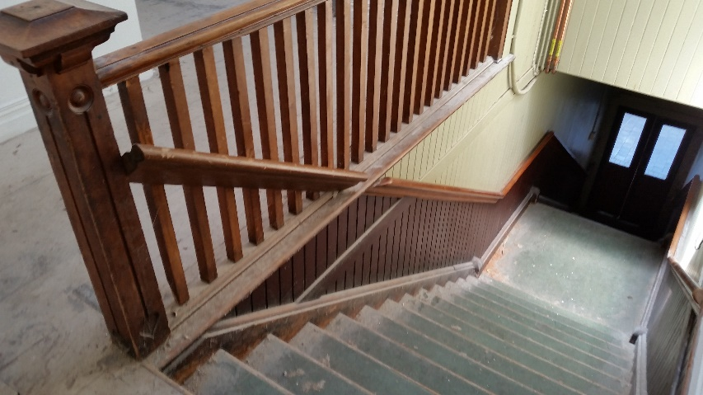
2.0 Objectives & Methodology
Figure 5: Building interiors

The purpose of the Proposed Feasibility Study is to:

- thoroughly establish the current structural and material condition of the three heritage buildings owned by Rangitikei District Council;

- evaluate the heritage significance of all building fabric (both interior and exterior) and prioritise building elements for retention;

- produce a concept design for adaptive reuse of the three buildings as the Marton Civic Centre, ensuring the ongoing use of these significant heritage buildings.

The Study has four key objectives, which will be achieved by following the methodologies outlined below.

Objective 1: Review and establish in greater detail the heritage significance of the buildings.

Heritage Assessments for all three buildings were prepared by Ian Bowman in 2014. However, these were very high level, and only considered the exterior of the buildings, focussing on their contribution to the townscape. As part of developing concept design options for the Civic Centre, the three existing buildings will be fully evaluated by a qualified and experienced Conservation Architect in their entirety, with both external and internal fabric assessed for significance and condition, to determine which parts of the building should be prioritised for retention on the basis of heritage value, and which parts of the building can (or should) be modified. This assessment will be made in accordance with the ICOMOS NZ Charter (Revised 2010) – particularly the principle of minimum intervention - and assessment guidance provided by Heritage New Zealand Pouhere Taonga.

Objective 2: Understand the engineering requirements and constraints of the buildings and site.

Initial Seismic Assessments (ISAs) for each building were completed by Charles Consulting Ltd in 2015, and reviewed by WSP Opus in 2016. These provided a valuable “first look” at the likely building performance as well as a benchmark for comparison with buildings of a similar age and construction. However, where important decisions need to be made regarding a building’s seismic status and how to strengthen it, an ISA provides insufficient information, and a Detailed Seismic Assessment (DSA) is required.
A DSA is a quantitative procedure that can take several forms, which have all been developed specifically for assessing existing buildings and, it is important to note, are not simply a back calculation of the design process used for new buildings. A DSA is used to confirm an earthquake rating for a building, particularly when a higher degree of reliability than considered available from a ISA rating is required. It can also be used to identify retrofit needs and provide a benchmark for proposed upgrading strategies to be tested against.
DSAs will be completed for all three buildings by qualified structural engineers with experience in historic building types and construction techniques. DSAs will include an outline condition evaluation which will be completed in consultation with a conservation architect and materials specialists as required.
A geotechnical desktop assessment will also be completed to understand the site-specific ground conditions.

Objective 3: Survey the existing buildings.

A complete drone survey of the existing buildings and adjacent street will be undertaken to provide a highly accurate base model upon which the concept design work will be based. The survey will be undertaken using motion photogrammetry: taking hundreds of photographs of the site from the ground and from the air by drone, and measuring specific features within the site by GPS and total station to bring the model into real coordinates and scale. The level of detail and accuracy that a survey of this nature will provide is far superior to traditional methods and has a two-fold cost benefit to the project through the direct saving in labour costs compared with a traditional building survey, and co-ordination of documentation and generation of presentation materials. It will also enable inspection of the first floor facades and roof of the building without special health and safety equipment.
A topographical survey will also be undertaken to establish existing kerb, channel, services and site features to inform concept design work and align with the drone survey.
Objective 4: Develop a brief and concept design for adaptive reuse of the existing heritage buildings as the Marton Civic Centre.

A brief will be developed by way of workshops involving Rangitikei District Council staff and consultants including the architect, conservation architect, and engineers.
This brief will then be overlaid with the information collected and constraints identified through Objectives 1, 2 and 3, in order to produce a concept design that meets the Rangitikei District Council’s functional requirements and achieves 100% of the New Building Standard while simultaneously protecting the buildings’ heritage values and significant fabric.

A full range of consultants will be engaged during concept design, including: architects; heritage and materials specialists; structural, services and fire engineers; and landscape architects to ensure that the result is as thorough as possible.

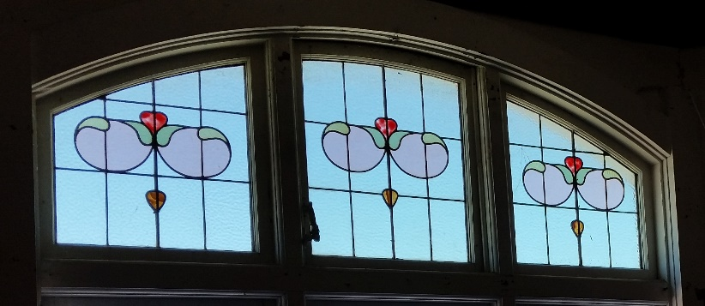
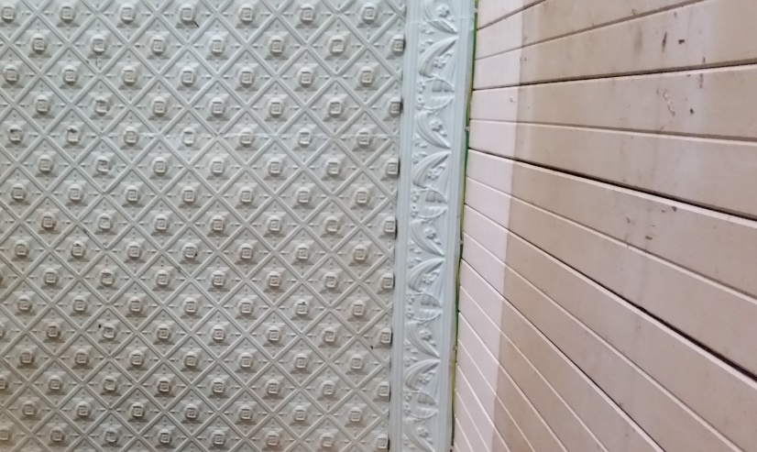
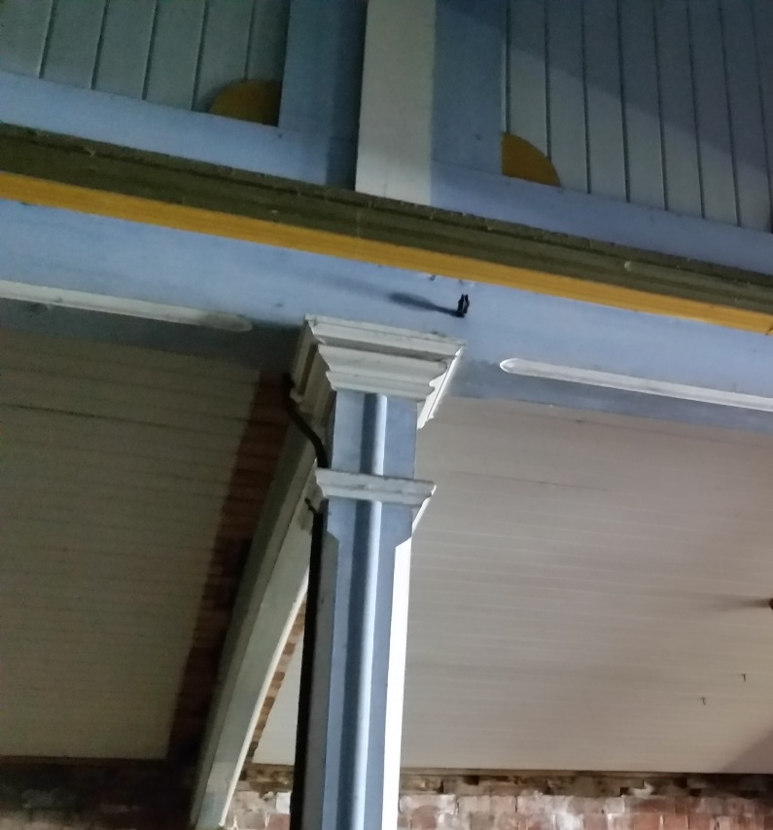
Figure 6: Building interiors

3.0 Presentation of Findings
The findings of the Proposed Feasibility Study will be presented as a comprehensive Concept Design Report in A3 landscape format. This will include the results of the assessments carried out; drawings showing the proposed floor plans, elevations, and 3D visualisations of spaces within the buildings, ready to be presented to the community for consultation and engagement.

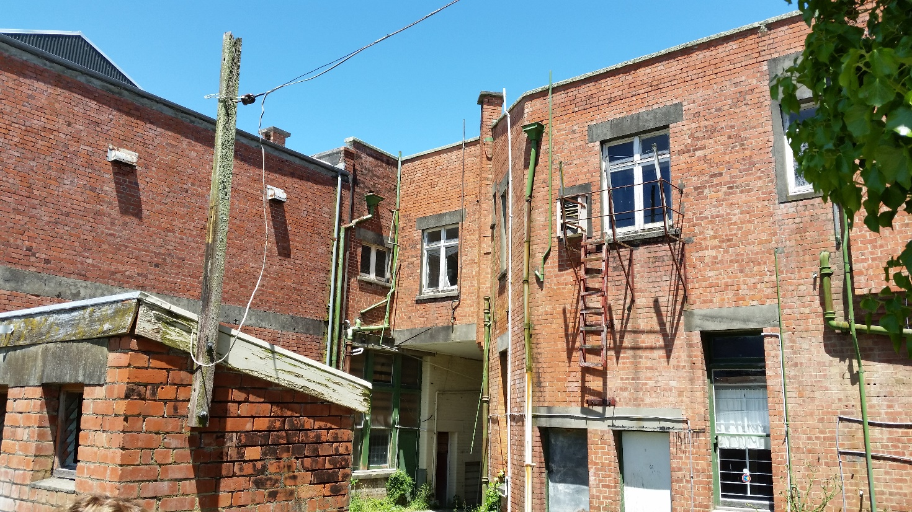
Figure 6: Rear of Cobbler and Davenport Buildings

4.0 Timeline for Delivery
The estimated timeline for delivery of the Proposed Feasibility Study is 25 weeks. The study has already commenced with the assistance of WSP Opus, and is due for completion in August 2019. This timeframe takes to completion of the project to well after the scheduled Lotteries Environment and Heritage Fund decision meeting on 12 June 2019. This approach is consistent with the Fund criteria.

5.0 Endorsement

See attached letter of endorsement
1 March 2019

To Whom It May Concern,

Marton Civic Centre: Proposed Feasibility Study
Independent Professional Endorsement for Application for Lottery Environment and Heritage Grant

My name is Chessa Stevens, Senior Heritage Consultant and Conservation Architect at WSP Opus (formerly Opus International Consultants). I am a Registered Architect with a Masters degree in Conservation Studies (Historic Buildings) from the University of York, United Kingdom. I am also the Co-Secretary and member of the Executive Board of ICOMOS New Zealand. I have been asked by the Rangitikei District Council to provide an endorsement of the proposed Marton Civic Centre Feasibility Study.
The Marton Civic Centre Precinct Feasibility Study builds on work undertaken by WSP Opus in December 2016. This work included a series of high-level concept designs for the three buildings that make up the proposed site of the Civic Centre on the corner of Broadway and High Street: the Abraham and Williams Building, the Davenport Building, and the Cobbler Building. All three buildings are listed as Category 2 Historic Places with Heritage New Zealand Pouhere Taonga and are scheduled as heritage buildings in the Rangitikei District Plan.
Ongoing use of a building is vital to its preservation. Where it is not possible to keep the building in the use for which it was designed, adaptive reuse – the process by which a building is adapted to suit the functions of a new use without substantially compromising its heritage significance and fabric – is an established way of ensuring that heritage buildings receive ongoing protection. Rangitikei District Council have seen the opportunity that adaptive reuse of their buildings offers to themselves and the community, and they are enthusiastic about the prospect of revitalising both the buildings and, as a consequence, the centre of Marton.
It is my opinion that this proposed Feasibility Study has been planned in accordance with sound conservation principles including the ICOMOS New Zealand Charter for the Conservation of Places of Cultural Heritage Value; and will provide Rangitikei District Council with a clear direction for future works that will explore some of the above opportunities, ultimately leading to restoration and protection of three highly significant heritage buildings, enabling public access and increasing public awareness of the importance of heritage retention.

Kind Regards
Chessa Stevens
Senior Heritage Consultant, Conservation Architect
MA Conservation Studies (Distinction), BArch (Hons), BA, ANZIA
Co-Secretary and Executive Board Member of ICOMOS New Zealand

Figures based on census data
Issues 4 and 16 of the Rangitikei District Plan
Earthquake-prone buildings are defined as those that fail to meet 34% of the current New Building Standard (NBS).
For a definition of concept design and the typical deliverables please refer to the Construction Industry Council (CIC) Guidelines.

